GOVERNMENT ENGINEERING COLLEGE, BHARUCH

Student's Weekly Report of Internship
Student Name: | PATEL BINIT UMESHKUMAR
Enrollment Number: | 230143107014
Week Duration: | January 29, 2026 - February 4, 2026 (Week 5)
Name Of Organization: | Microsoft Elevate Program (via Edunet Foundation & FICE Education)
External Guide Name: | Adarsh Gupta
External Guide Contact: | 0124-4080107

Work done in last Week with description:

1. Week 5 Module: Supervised Learning

Description:
Attended comprehensive session on "Supervised Learning" on February 20, 2026. Learned about supervised learning algorithms, their applications, and hands-on implementation using scikit-learn library.

Key Topics Covered:
- Supervised learning concept: learning from labeled data
- Regression vs Classification problems
- Linear Regression: theory and implementation
- Logistic Regression for classification tasks
- Decision Trees: structure, splitting criteria, pruning
- Random Forest ensemble method
- Support Vector Machines (SVM) basics
- K-Nearest Neighbors (KNN) algorithm
- Train-test split and cross-validation techniques

Hands-on Practice:
Implemented Linear Regression on Boston Housing dataset. Trained a classification model using Iris dataset with Decision Tree and Random Forest algorithms. Learned to evaluate models using accuracy, precision, recall, and F1-score metrics. Practiced splitting data into training and testing sets (80-20 split).

Code Practice:
Used scikit-learn library to import datasets, preprocess data, train models, and evaluate performance. Practiced hyperparameter tuning and compared different algorithm performances.
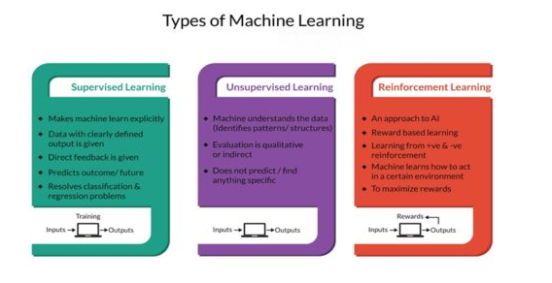

2. Week 5 Module: Unsupervised Learning

Description:
Participated in "Unsupervised Learning" session on February 23, 2026. Explored clustering algorithms, dimensionality reduction techniques, and their practical applications in data analysis.

Key Topics Covered:
- Unsupervised learning: learning from unlabeled data
- Clustering algorithms and applications
- K-Means clustering: algorithm, initialization, convergence
- Hierarchical clustering: agglomerative vs divisive
- DBSCAN (Density-Based Spatial Clustering)
- Dimensionality reduction techniques
- Principal Component Analysis (PCA)
- Elbow method for optimal cluster selection
- Anomaly detection using clustering techniques

Practical Implementation:
Applied K-Means clustering on customer segmentation dataset. Used Elbow method to determine optimal number of clusters. Implemented PCA for dimensionality reduction on high-dimensional data. Visualized clusters using matplotlib and seaborn libraries. Understood how clustering can be used for anomaly detection, which is relevant for surveillance project.

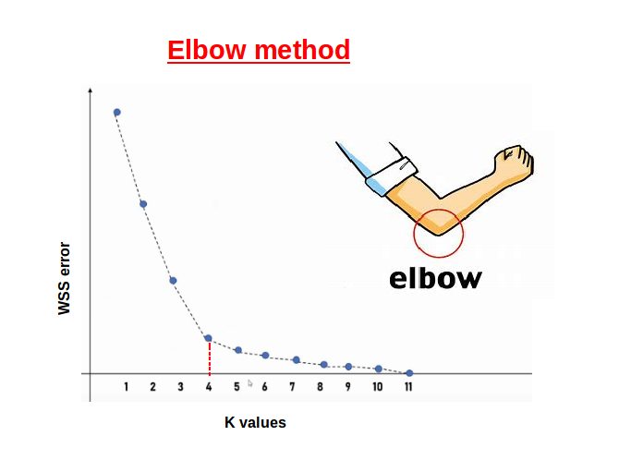

3. Week 5 Module: Reinforcement Learning

Description:
Attended "Reinforcement Learning" session on February 25, 2026. Learned about RL fundamentals, agent-environment interaction, and explored basic RL concepts with simple examples.

Key Topics Covered:
- Reinforcement Learning fundamentals: agent, environment, actions, rewards
- Markov Decision Process (MDP) framework
- Exploration vs Exploitation trade-off
- Q-Learning algorithm basics
- Policy: deterministic vs stochastic
- Value functions and Bellman equation
- Applications: game playing, robotics, autonomous systems
- Difference between RL and Supervised/Unsupervised learning

Examples and Demonstrations:
Explored classic RL examples like grid world navigation and game playing agents. Understood how RL agents learn optimal policies through trial and error. Discussed real-world RL applications in recommendation systems, robotics, and autonomous vehicles. Recognized that RL is more advanced and typically not used in basic object detection tasks.
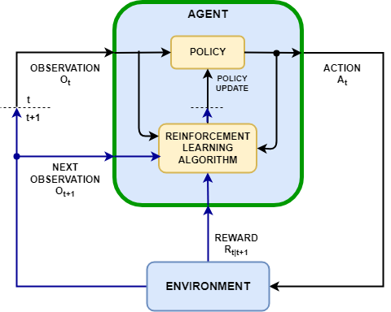

4. Machine Learning Assignment Completion

Description:
Completed comprehensive Machine Learning assignment covering supervised and unsupervised learning techniques. Implemented multiple algorithms and compared their performance on different datasets.

Assignment Tasks:
- Task 1: Linear Regression on housing price prediction dataset
- Task 2: Classification using Decision Tree and Random Forest on Iris dataset
- Task 3: K-Means clustering on customer segmentation data
- Task 4: Model evaluation using confusion matrix, ROC curves
- Task 5: Hyperparameter tuning using GridSearchCV
- Created Jupyter notebook with complete code and visualizations
- Submitted assignment to MS Elevate portal

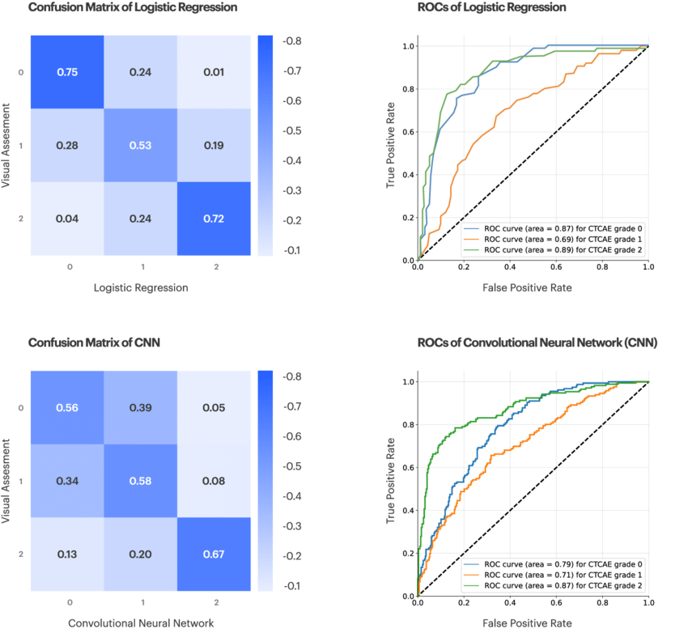
Figure: Example of confusion matrix and ROC curve used for evaluating classification model performance.

5. Scikit-learn Library Deep Dive

Description:
Spent dedicated time exploring scikit-learn library documentation and practicing various ML workflows. Built strong foundation in using scikit-learn for future project implementation.

Skills Developed:
- Data preprocessing: StandardScaler, MinMaxScaler, LabelEncoder
- Train-test split and cross-validation (KFold, StratifiedKFold)
- Model training: fit(), predict(), score() methods
- Model evaluation metrics: accuracy_score, precision_recall_fscore_support
- Pipelines for streamlined ML workflows
- Feature selection and extraction techniques

6. GTU Project - GitHub Repository Setup

Description:
Created GitHub repository for the Border Surveillance project and setup initial project structure. Minimal development work as focus remained on completing ML modules this week.

Setup Completed:
- Created repository: github.com/[username]/Border-Surveillance-AI
- Initialized with README.md, LICENSE (MIT), and .gitignore
- Created folder structure: data/, notebooks/, src/, models/, docs/
- Wrote project description in README with objectives and tech stack
- Added requirements.txt with essential libraries

Note:
Deep Learning and CNN modules in Week 6-7 are essential prerequisites for implementing YOLOv8 object detection. Project development will accelerate after completing these modules.

Plans for next week (Mar 3-7, 2026):

1. Complete Week 6 Microsoft Elevate Modules
- Attend "Deep Learning" fundamentals session (Feb 27)
- Participate in "Artificial Neural Networks (ANN)" session (Mar 2)
- Learn neural network architecture and backpropagation
- Practice building neural networks with TensorFlow/Keras

2. Install and Setup Deep Learning Environment
- Install TensorFlow 2.x and Keras
- Setup GPU support (if available) or use Google Colab
- Test basic neural network training
- Learn Keras Sequential and Functional API

3. Neural Network Fundamentals Practice
- Study activation functions: ReLU, Sigmoid, Tanh, Softmax
- Understand forward and backward propagation
- Practice with loss functions and optimizers
- Build simple feedforward neural network on MNIST dataset

4. Prepare for CNN Module (Week 7)
- Read about Convolutional Neural Networks basics
- Understand concepts: convolution, pooling, feature maps
- Study popular CNN architectures: LeNet, VGG, ResNet
- Prepare questions for CNN session

5. Update Project Documentation
- Add project architecture diagram to repository
- Document ML learning progress and key concepts
- Plan YOLOv8 implementation strategy for Week 7-8

Total Working Hours: 34 hours
Signature of Student: _____________________
The above entries are correct, and the grading of work done by Trainee is:
Excellent | Very Good | Good | Fair | Below Average | Poor
☐ | ☐ | ☐ | ☐ | ☐ | ☐

Signature of External Guide with Company Seal: _____________________
Date: ___________
Signature of Internal Guide: _____________________
Date: ___________

